**SOFTWARE**

**REQUIREMENTS**

**SPECIFICATION**

**For**

**Online Job Search**

**Prepared by:-**

**Vishnu Priya.S**

**Chithra Banu.V**

**Deepika.B**

**Sofia.M**

**Vaishnavi.A**

**Keerthana.R**

**Academic Year:** 2023-2024

**1. INTRODUCTION**

**1.1 Purpose**

Thepurpose of **Software Requirements Specification (SRS)** document is to describe the externalbehavior of the Online Job Portal System. Requirements Specification defines and describes the operations, interfaces, performance, and quality assurance requirements of the Online Job Portal System. The document also describes the non-functional requirements such as the user interfaces. It also describes the design constraints that are to be considered when the system is to designed, and other factors necessary to provide a complete and comprehensive description of the requirements for the software. The Software Requirements Specification (**SRS**) captures the complete software requirements for the system, or a portion of the system. Requirements described in this document are derived from the Vision Document prepared for the Online Job Portal System.

**1.2 Document Conventions**

* Entire document should be justified.
* Convention for Main title
* Font face: Times New Roman
* Font style: Bold
* Font Size: 14
* Convention for Sub title
* Font face: Times New Roman
* Font style: Bold
* Font Size: 12
* Convention for body
* Font face: Times New Roman
* Font Size: 12

**1.3 Scope**

The Software Requirements Specification captures all the requirements in a single document. The Online job Portal System that is to be developed provides the members with jobs information, online applying for jobs and many other facilities. The Online Job Portal System is supposed to have the following features.

1.2.1 Main Page

Search jobs, browse jobs by country, by category or by agency. Latest jobs listed on the front page.

1.2.2 Job Seeker’s Area

Jobs seekers can sign-up and submit their resume or manage their Job Alerts. Job seekers can manage other things associated with their account.

1.2.3 Agency’s Area

Agencies can sign-up and browse job seeker’s resumes, manage their advertisements (job postings) or manage their Resume Alerts. Additionally, job seekers can submit their profile and manage other things associated with their account.

1.2.4 Administration Panel

The job board is highly configurable and there are many possibilities for running the job board. The administration panel consists of a set of web pages where you can:

* Approve / Disapprove / Edit / Delete job postings.
* Approve / Disapprove / Edit accounts with the click of a button.
* View / Edit / Delete resumes.
* View/Edit/Delete Emails.

The features that are described in this document are used in the future phases of the software development cycle. The features described here meet the needs of all the users. The success criteria for the system are based in the level up to which the features described in this document are implemented in the system.

**1.3 References**

[1]Catherine Ricardo, Iona College New Rochelle, New York, Database Systems Principles, Design, and Implementation, New York: Maxwell Macmillan,1990.

[2] Jeffery L. Whitten, Lonnie D. Bentley, Kevin C. Dittman, Purdue University, West Lafayette, IN, Systems Analysis and Design Methods, 6th edition, New York: McGraw-Hill/Irwin, 2004.

[3] Wikipedia website <URL:http://en.wikipedia.org>

[4] Information on the XAMPP is available at Apachefriends

website <URL:http://www.apachefriends.org/en/xampp.html>

[5] Answers website <URL:http://www.answers.com>

**2. Overall Description**

**2.1 Product Perspective**

The Online Job Portal System is a package to Avachromians/MIT be used by agencies to improve the efficiency of business. The Online Job Portal System to be developed benefits greatly the members. The system provides jobs catalog and information to members and helps them decide on the jobs to apply. The Admin can keep the jobs catalog updated all the time so that the members (Job seekers and the agencies) get the updated information all the time. The main users are users: Admin, Members who are the Job seekers and the agencies.

**2.2 Product Functions**

The Online Job Portal System provides online real time information about the jobs available in the agencies and the user information. The functions of the system include λ The member should be provided with the updated information about the jobs catalog λ Provisions for the members to apply the job they want, if all the other required rules hold good. λ the member is given a provision to check his account information and change the account information λ any time in the given valid period. λ the members are provided with the jobs available roster and allowed to apply job, which they want. λ The admin can get the information about the members who have advertised jobs.

**2.3 User Characteristics**

The users of the system are members and the admin who maintain the system. The members are assumed to have basic knowledge of the computers and Internet browsing.

**2.4 Operating Environment**

There should be proper commitment of Hardware and communication gears should be equally coupe with each other, it may help to prevent many inconveniences during the Browsing. Those requirements have been Eplained later headings.

* Web Browsers[Java Script enabled]
* Google Chrome
* Internet explorer
* Mozilla Firefox
* Operating Systems and versions.
* All the Windows OS versions.

**2.5 Assumptions and Dependencies**

• The user should have sufficient knowledge about computers.

• The computer should have internet connection and Internet server capabilities.

• The users know the English language, as the interface will be provided in English.

**2.6 Software Interface**

Front End Client:

Html

Web Server:

WASCE

Data Base Server:

DB2

Back End:

Python

**2.7 Hardware Interface:**

Client Side: PC (Monitor)

Server Side: PC

**2.8** **Constraints :**

The users access the Online Job Portal System from any computer that has Internet browsing capabilities and an Internet connection.

PERFORMANCE REQUIREMENTS:

Performance is measured in terms of the output provided by the

application. Requirement specification plays an important part in the

analysis of a system. Only when the requirement specifications are

properly given, it is possible to design a system, which will fit into

required environment. It rests largely in the part of the users of the

existing system to give the requirement specifications because they are

the people who finally use the system. This is because the requirements

have to be known during the initial stages so that the system can be

designed according to those requirements. It is very difficult to change

the system once it has been designed and on the other hand designing a

system, which does not cater to the requirements of the user, is of no

use.

The requirement specification for any system can be broadly stated

as given below:

The existing system is completely dependent on the user to perform all

the duties.

**3.1 System Features**

Modules of project:

The project can be divided into three main modules.

* **Jobseeker**
* Advanced job search functions.
* Register for a jobseekers account.
* Build your profile.
* Build online CV.
* Build multiple cover letters.
* **Agency**
* Advanced CV search functions.
* Purchase advertising credits via credit card or invoice.
* Enable/Disable CV database access.
* Edit/Delete job vacancies.
* **Administration**
* Multiple administration accounts.
* Live statistics.
* Accept payments.
* View/Edit agencies account balance.
* Create resources.

**4. Non Functional Requirements**

**4.1 Performance Requirements**

**Server Side**

The web application will be hosted on one of the windows serves.

**4.1.1 The ideal specifications for the server machines**

* Intel Core 2 Duo Extreme-2 GHz
* 8GB of RAM
* Running Windows Server
* A commercial Web Application Server
* At least five 3rd party machines for clustering

**4.1.2 The minimal specifications for the server machine**

* Intel Core 2 Duo-1.86 GHz
* 2GB of RAM
* Running Windows XP
* Apache Tomcat Server

**4.1.3 The ideal requirement for a client PC logging into the system**

* Intel Pentium IV or equivalent processor-2.0 GHz or above
* 1GB RAM
* Running Windows XP/Vista/Win7
* Mozilla Firefox with JavaScript enabled
* ADSL Internet Connection with 512kbps bandwidth

**4.1.4 The minimal specifications for the PC used for server clustering**

* Intel Celeron or equivalent processor-1.5 GHz or above
* 512MB RAM
* Running Windows XP or equivalent
* Internet Explorer 6 or later with JavaScript enabled
* ISDN Internet Connection with 128kbps bandwidth

**4.2 Safety Requirements**

Highly recommend Kaspersky 2010 internet security to been Installed in users Pc to prevent the harm that may occurs by Unwanted malicious software’s, phishing URLs and all the types of Virus attacks during using this application.

**4.3 Security Requirements**

All users should be properly authenticated before allowed entry into the system Authentication will be based on a E-mail address, and a password. All activities on the system must be logged.

**Use case Diagram**

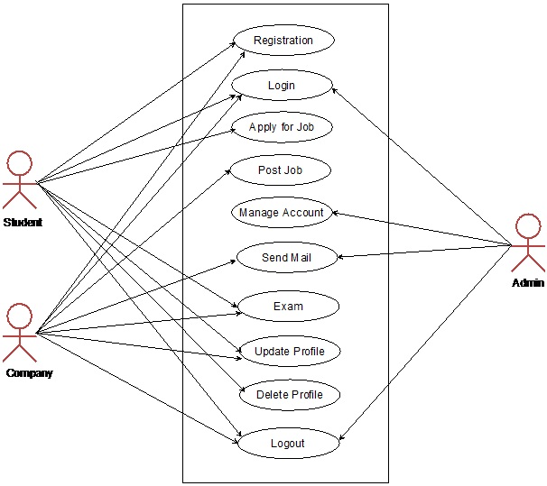

**Class Diagram**

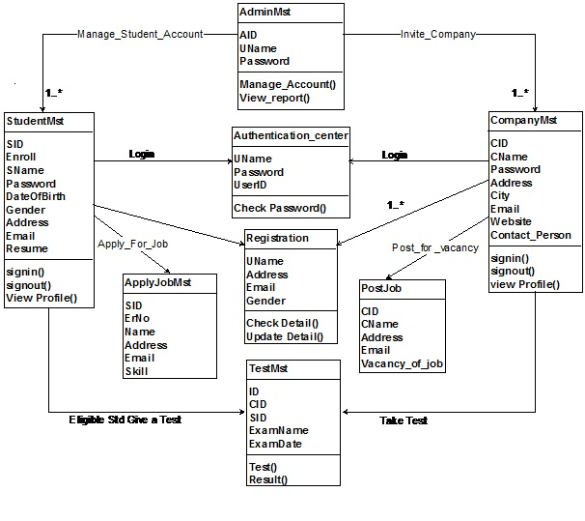

**Activity Diagram**

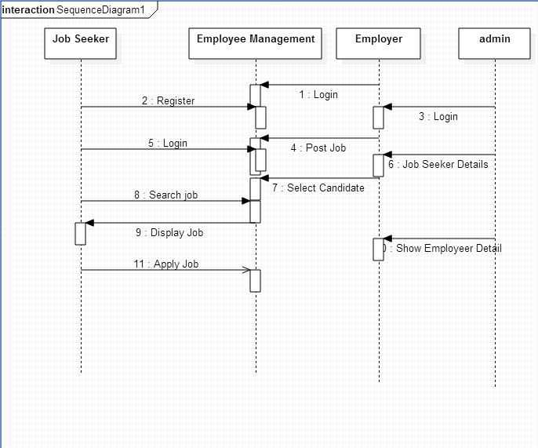

**Screenshots**

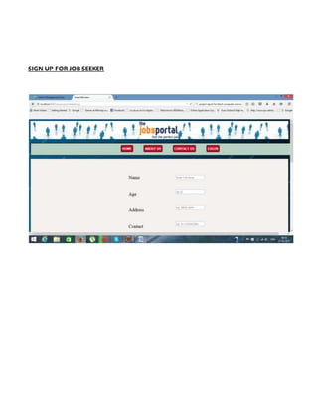

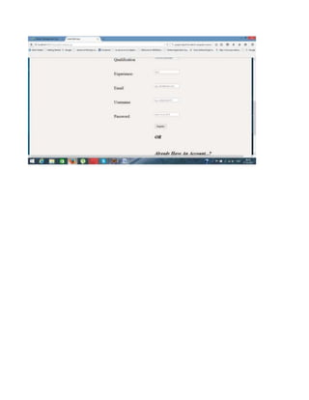

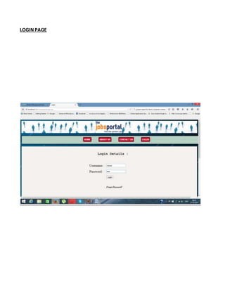

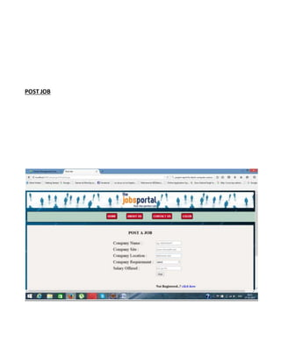

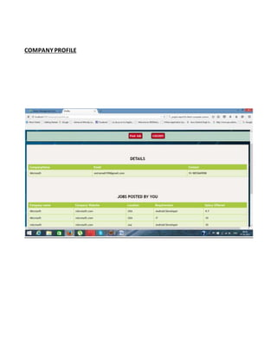

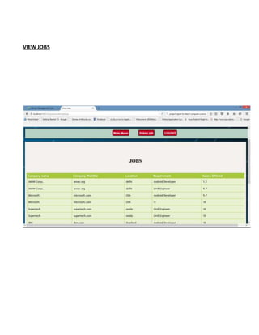

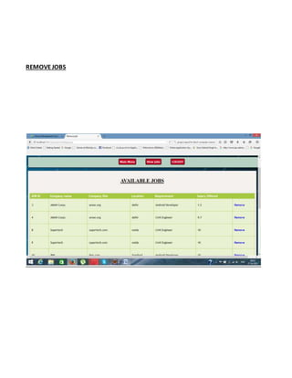

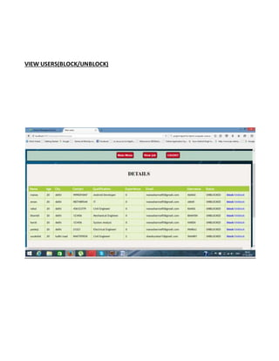

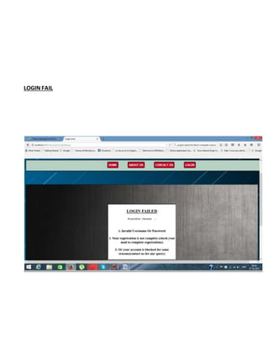

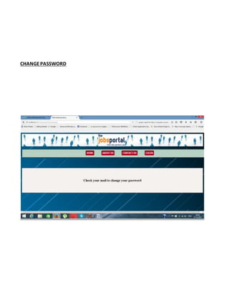

**CONCLUSION**

* In the past the only media for job search was the NEWS paper, T.V., and radio.
* There was also Employment Exchange where the people used to get registered, based on which priority was given for jobs. It exists even today.
* Now-a-days there are several online job searching websites available but these websites provide only specific services.
* So we are developing a project which provides the required features to job providers, job seekers and e-learners.

**THANK YOU**